1. Present
Pat Arnott, Ursula Smith, Chris Lowndes, Stacy Mound, Julie Tinsley, Jeanette Pointon, Jess Mountford, Julie Dolman & Sam Oldfield

2. Apologies
Rebecca Barnes, Suzanne Lawton & Bernadette Hancock

3. Minutes from last AGM
Signed as a true record

4. President’s Report
Report from Ursula Smith. Another busy year for Staffordshire netball and a big thank you to all the volunteers- coaches, umpires and administrators of all kinds- who ensure netball at every level continues to thrive in our county.
The value of the coaching received by Staffordshire youngsters has become apparent as our top teams mature. They play for clubs who continue to improve and progress towards the next stage on the netball ladder. Congratulations to Newcastle Town for making the play-offs for the National Premier League and to Fenton Manor for reaching the last four in the Regional League play-offs.
From next season, the number of youngsters being coached in our academies will be reduced significantly. The extra time devoted to these talented athletes must ensure they have a very bright netball future. How are we going to ensure that the youngsters who would normally have trained at that level still reach their potential? This is not only important for the individuals concerned but also very important for our clubs.
Looking to the future, we will need to think creatively to make sure that all our talented young players have the opportunity to develop along the pathways that are already very congested. We also need to encourage our youngsters to consider following a coaching or umpiring pathway and try to include more of them in the administrative work undertaken so willingly by our older members.
“Some people want it to happen, some wish it would happen, others make it happen!” -Michael Jordan
5. Annual Reports

5.1 Treasurers Report
Report presented by Chris Lowndes. No problems, the county have a healthy balance. We perhaps need to channel some of the money into something soon. Although income looks more than expenditure, the academy coach invoices are due in so this will break even. More money has gone out due to umpire testing and the “other” pot relates to tournaments, B2N, etc. Chris is to investigate the deposit account to see if a better interest rate can be achieved.
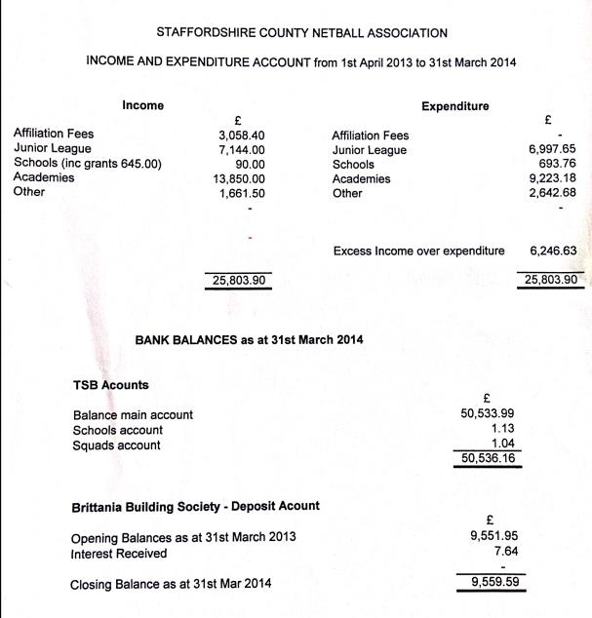
Figure 1: Financial Summary 2013-2014

5.2 Coaching Report
Report presented by Pat Arnott. Coaching courses have been held in the region with some achieving Level 1 and Level 2. Julie Dolman has nearly completed here Level 3. Format of the academies has changed with folders coming from EN to support player’s progression. I hope that everyone has gained some support and knowledge from the experienced coaches who have support the academies this year.

5.3 Umpiring Report
No report, Rebecca Barnes not present. A small summary provided - approx. 8 C Award umpires passed this year with Rebecca Barnes and Sam Oldfield now umpiring at West Midland’s regional league and progressing towards their B Award. We need to gain more tutors and mentors to support county progression. Unfortunately, Rebecca Barnes is resigning from the role of umpiring secretary this year – thanks given for her work in the role.

5.4 Schools Report
No report, position vacant. The committee given thanks the Suzanne Lawton and Staffs supporters for their help organising the West Midland’s schools tournament. Thanks are given to Ursula Smith for organising the National School’s tournament and Stafford Sport College for the use of their facilities. Finally, thanks are given to Julie Dolman for organising the High-5 tournament. Winners are as follows:

5.5 Excel Academies
Report presented by Jeanette Pointon. Everything has been good. U16/U16 development have been coached by Esther Rutherford and Julie Dolman, U14 North coached by Jeanette Pointon and Rachel Deakin and U14 South coached by Tracey Turner and Sally Kendrick. Some players were selected for the West Midlands level so they could not attend county sessions so it is an excellent endorsement for Staffs academies. We need to think next year about how everything will run with changes to the coaching staff and academy structure.

5.6 Tournament Report
Queensbury plate this year was won by MOTHS B and runners-up Potters Ladies. Joyce Haynes scheduled for 19th May 2014. We aspired to organise an U12 tournament but this was not achieved due to lack of personnel – this is something we should be providing, perhaps with the support of SASSOT and school-games organisers.

5.7 Staffordshire Junior League Group Report (Junior SCNA)
Report presented by Ursula Smith. Although there are only 5 clubs with teams playing in the County Junior League, there are 30 teams competing in the 3 age groups. Julie Tinsley continues to do the sterling work of sorting out the fixtures. Thank you! Thanks also to the results officers who have done such a great job this season.

The Young Organisers’ course held at Stafford Sports College before Christmas attracted 19 aspiring young leaders, some of whom used their skills in the league as well as at various schools’ events.
Stafford and Newcastle Town represented Staffordshire in the Under 14 West Midlands Regional League coming 7th and 11th respectively. Newcastle Town and Fenton Manor were our Under 16 representatives, finishing in 8th and 11th place. Congratulations to these teams for their County level success and regional endeavour!
Tean Valley raised money for league funds with a Christmas raffle. Thank you!
The Staffordshire County Presentation Evening is being held at the Moat House, Festival Park on Friday, May 16th. Over 250 guests will be celebrating Staffordshire’s netballing successes for 2013/14. Tean Valley player, Brogan Griffiths, has accepted the invitation to present the trophies. Brogan will be playing for England U21 team at the Indoor Netball championships in South Africa at the end of May. It is lovely for all to see a Staffordshire player who trained at our academies doing so well.
Finally, thanks to all the volunteers who make sure that so many youngsters in Staffordshire have the opportunity to play netball in a safe and enjoyable environment. You are all stars!
Thanks given to Ursula from the committee for all her hard work.

6. Constitution Changes
No changes to the constitution this year.

7. Election of Officers
No nominations, Rebecca Barnes and Jeanette Point have resigned from their roles as umpiring secretary and vice-chair/excel academy head coach respectively. New committee members as below.

Position | Member | Vote
President | Ursula Smith | Carried
Chair | Pat Arnott | Carried
Vice-Chair | Sam Oldfield/Ursula Smith | Carried
Secretary | Sam Oldfield | Carried
Treasurer | Chris Lowndes | Carried
Assistant Treasurer | Jessica Mountford | Carried
SJLG Co-ordinator | Ursula Smith | Carried
Affiliation Secretary | Julie Tinsley | Carried
Schools Secretary | Jeanette Pointon | Carried
Umpiring Secretary | Vacant | Temporary: Chris Lowndes
Tournament Secretary | Sue Lawton | Carried
Coaching Secretary | Pat Arnott | Carried
Publicity Secretary | Vacant | Enquiries to be made
Excel Academy Head Coach/Scout | Vacant | Enquiries to be made
Academy Safeguarding Officer | Julie Tinsley | Carried
Committee Members | Norma Ashcroft  Stacy Mound  Julie Dolman  Sally Kendrick | Carried  Carried  Carried  Carried
Representative from each Staffordshire League | Sophie Bridgwood  Stafford League Rep TBC | Carried

8. Affiliation Fees for 2013/2014 Season
No changes to county rates but we may alter our rates to round up/down fees once England Netball and West Midlands announce their costs.

Update: since the AGM England Netball have released their fees as follows with a slight increase in charges:

EN Affiliations | Cost
Over 18 | £25.50
18 and under | £16.00
14 and under | £8.40
12 and under | £5.20

9. Date of AGM 2014
Thursday 14th May 2015, 7:30pm.

Meeting closed at 9:00 pm.

